Requirements Specifications Document
for

BioBigBox (Local Backup Option)

Prepared By: | Rahul Parikh | Reviewed by: | Ronak Shah
Version No: | 1.0 | Issue Date: | 30-07-2016

Document Revision History
Revised By | Revised Date | Version | Reviewed By | Comments
Rahul Parikh | 30-07-2016 | 1.0 | Ronak Shah | Initial Version

Status

Approved By
Department | Name | Date | Comments

Table of Contents
Contents
Document Revision History 2
Status 2
Approved By 2
Table of Contents 3
1 Introduction 5
1.1 Document Purpose 5
1.2 Project Background 5
1.3 New Feature 5
1.4 Definitions, Acronyms and Abbreviations 5
2 High Level Requirements 6
3 Detailed Functional Requirements 7
3.1 Configuration For Local Sync 7
3.2 Change Backup Destination 7
3.3 Restore from backup 7
3.4 Backup Frequency 8
3.5 Daily Notification mail 8
3.6 Document Versioning 8
4 Validations 9
5 Security 10
6 Assumptions 11
7 Sample Screens 12
7.1 Sample Screen 1 12
7.2 Sample Screen 2 12
7.3 Sample Screen 3 12
7.4 Sample Screen 4 13
7.5 Sample Screen 5 13
7.6 Sample Screen 6 13
7.7 Sample Screen 7 14
7.8 Sample Screen 8 14
7.9 Sample Screen 9 15
7.10 Sample Screen 10 15
7.11 Sample Screen 11 16
7.12 Sample Screen 12 16
7.13 Sample Screen 13 16
7.14 Sample Screen 14 17
7.15 Sample Screen 15 17
7.16 Sample Screen 16 17

Introduction

Document Purpose
The purpose of this document is to define the detailed requirements Specifications for the new Local Backup feature to be added in the existing Bio Big Box application. These requirements describe the details feature set that the Bio Big Box Application should support after new feature.

Project Background
Purpose of developing Bio Big Box application is to allow its user to take the backup of their data on secure cloud which stores data into HIPPA Compliant. Also user will be able to restore the data as and when required from the cloud to his desired location. Based on the selected subscription plan the user will be allowed to backup data.

New Feature
New feature to be added to existing application allow a user to choose to have the same data synced to a local external hard drive in secure and HIPPA Compliant Way. This functionality will offered only to paid account users or will require payment after the first X GB is backed up. Biobigbox.com already has paid accounts and accepts payment, but the accounts will need to be updated to include this functionality. This functionality will need to be active only if the user meets the paid requirements.

With this new feature user will be able to select one of three options. 1) Local sync only 2) Cloud sync only 3) Sync to both and will be able to restore the data from the respective backup location.

Definitions, Acronyms and Abbreviations
# | Acronym | Description
1 | BBB App | Bia Big Box Application

High Level Requirements

New Feature of Local Sync – This should allow user to sync the data on to the external hard disk.

The new feature will only be available to the users who satisfy paid account requirements.

User should able to select any of three sync option 1) Local Sync 2) Cloud Sync 3) Sync to Both.

Document revision history should be maintained for each file that is getting backed up and should be stored to the same external hard drive.

Configuration to be provided for enabling the Document revision. The user should be able to choose to “keep past file revisions”. The user can choose between “keeping revisions based on available hard drive space” (it will keep revisions until the hard drive is full and then delete the oldest) or “keep X number of revisions per file.

All the data on the stored hard drive needs to be secure and meet HIPPA Compliance.

Sync Operation should not start until user logs in to BBB App.

Detailed Functional Requirements

Configuration For Local Sync
>>During installation of the desktop application the user should be presented with the three options as well as one of the installation stages. If they select the option for local backup but do not have a relevant hard drive attached (the system should check) they should be told to change their settings later when they have a hard drive attached and shown a link where they can buy the hard drive.
- New Configuration added to configure the sync option. Based on the selected option the data will be backed up.
- Below three options will be added and available as new menu option
- Local Sync Only
- Cloud Sync Only
- Sync to both
Sample Screen1 (Windows)
Sample Screen 9 (Mac OS)
- When User selects Local Sync/Sync to both, then a pop up will appear asking for the external hard disk to use for the backup. This popup will contain a drop down which will contain list of all the attached external storage devices
Sample Screen2 (Windows)
Sample Screen10 (Mac OS)
- If user select the external storage device and press ok, that device will be configured to store the backup of the folder selected through BBB. We will store the details of the external storage device so next time whenever we attach this device to same system we can identify it
>> If there is data on the drive the user should be asked if they want to delete the data, keep the data or add to the bbb backup and restore to computer in designated folder.

Change Backup Destination
- While changing a destination drive user will be asked to Delete the data from existing Drive or keep it.
>> There should be a third option of adding the data to BBB backup (which would sync it to computer in the designated folder)
Sample Screen 3 (Windows)
Sample Screen 11 (Mac OS)
- If user selects delete, then a popup window will appear asking user to type “DELETE” keyword.
Sample Screen 4 (Windows)
Sample Screen 12 (Mac OS)
- After that a confirmation popup will be displayed saying the action is not reversible.
Sample Screen 5 (Windows)
Sample Screen 13(Mac OS)

Restore from backup
Based on the configured sync option a restore popup will be displayed.
- If sync option is only Cloud, then current flow will continue.
- If sync option is only local, then a new window will appear containing the local folders user has selected as backup on external hard disk. The data will be displayed in the tree structure with all the available version of the file.
Sample Screen 6 (Windows)
Sample Screen 14 (Mac OS)

- If sync option is both (Local & Cloud) then, a window will appear asking from where to backup and based on the selected option either of above two flows.
Sample Screen 7 (Windows)
Sample Screen 15 (Mac OS)
>> Wouldn't the data in both places be exactly the same, unless one sync did not finish successfully? The preferred option should be the local hard drive and that should be the option selected and it should say "(recommended)" next to it. We should also show the amount of data stored for each option next to the option itself.
- While restoring from Local Backup, the current file will be stored as revision, and will be overwritten by the selected revision file

Backup Frequency
- Data will be backed up immediately after any file or folder change using existing monitor Service.

Daily Notification mail
- Based on the selected sync option, a backup status mail will be sent contacting success/failure. For this enhancement existing email functionality will be used.
- If local sync fails because of disk space, the notification mail should contain the instruction to assign new destination folder for sync.
>> If the user is saving multiple versions they should be given the option to either reduce the number of versions or keep revisions based on available hard drive.

Document Versioning
- If user has enabled document Versioning then Versioning history of each document should be kept along with original document on the external drive.
- There will be two configuration will be available for document versioning
- Keep revisions based on available hard drive space
- Keep X number of revisions per file
Sample Screen 8 (Windows)
Sample Screen 16 (Mac OS)
- Based on the selected option the versioning will take place.

Validations
- The Local Sync option should only visible to paid user.
- Before taking backup of the files, check is the selected hard disk has enough space or not. If there is no enough space give a notification to user.
- If the hard drive is full, the user needs to be notified via email and on screen.
- If any of the sync had problem other sync option should work normally.
- The backup folder should remain hidden until user logs in to BBB app.

Security
- All the backup data will be saved using AES encryption algorithm on the external hard disk.
- The data will be retrieved only through BBB application in case restore is required.
- The backup data on the external hard disk will be visible only after user logs into BBB application.
Note: User should have to log off properly through BBB application before detaching the hard disk / shutting down system to properly hide the data on log off.

Assumptions
- For local backup, no information needs to be sent to cloud server regarding files getting backup
>> There needs to be an indication sent to the server if the files were backup up successfully.
- As we will store the backup data into encrypted form, the backup files will be visible to user, but when user opens that file it will be not in readable form.
>>This is assuming they are logged in and have entered the hard drive pin - correct?
- Size of the version files will not be considered into backup limit size.
>>It will be considered to calculate hard drive available space - correct?
- The visibility of backup folder will only be maintained if user logs in and logs out properly.
- It is not possible to make the backup folder hidden if the user detaches without logging out and then attaches the hard drive again to the same computer or a different computer the files should not be visible as we will not have control on the detach event of hard disk.

Sample Screens

Sample Screen 1
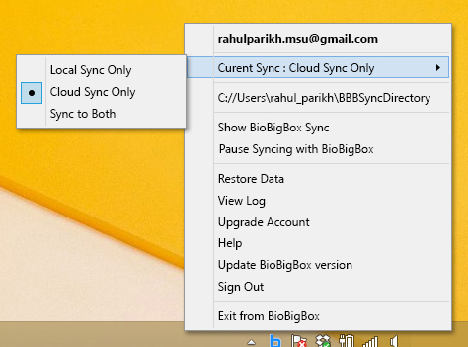
>> Options should be
-Local Backup
-Cloud Backup
-Local and Cloud Backup

Sample Screen 2
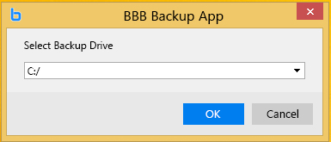

Sample Screen 3
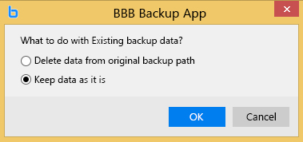
>>
"
There is data already saved on your external hard drive:
- Delete existing data
- Keep existing data on hard drie
- Add existing data to BioBigBox sync folder
"

Sample Screen 4
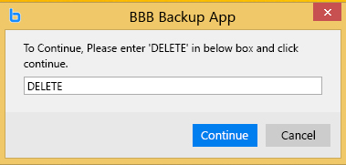
>>
"Please type "DELETE" in the box below to confirmation deletion."

Sample Screen 5
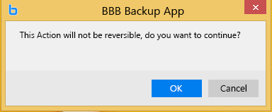
"This action is NOT reversible and the data will be permantenly deleted. Do you want to continue?"

Sample Screen 6
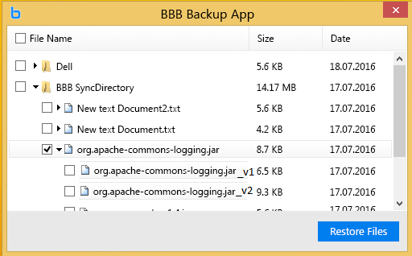

Sample Screen 7
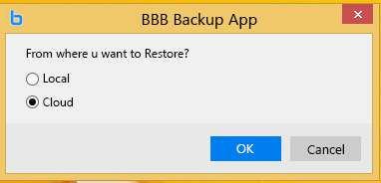
>> "
Restore data from
Local backup (recommended) xGB
Online backup xGB
"

Sample Screen 8
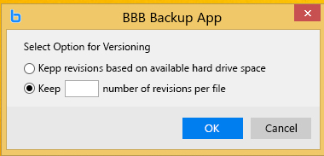
"Same file revisions
-Based on available hard drive space
- Keep X revisions per file
"

Sample Screen 9
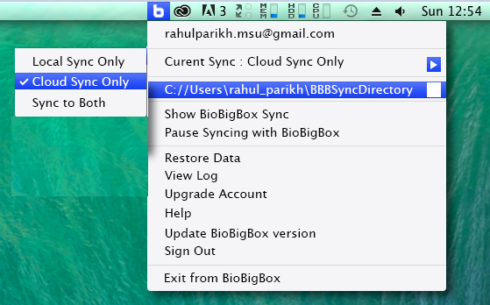

Sample Screen 10
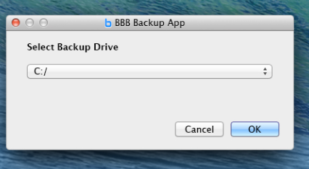

Sample Screen 11
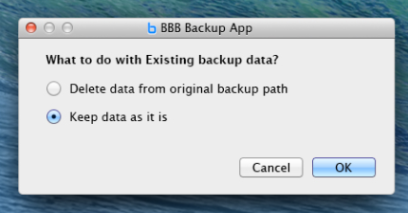

Sample Screen 12
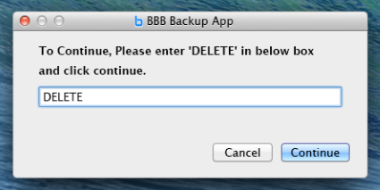

Sample Screen 13
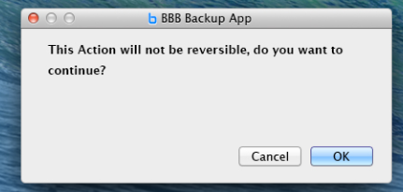

Sample Screen 14
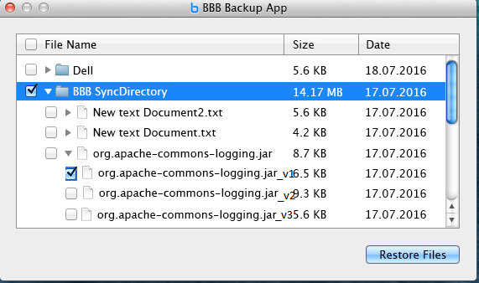

Sample Screen 15
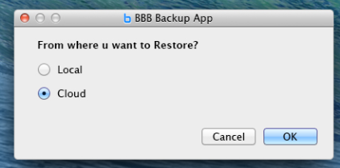

Sample Screen 16
